**Supplementary Information for “Representation of global change drivers across biodiversity datasets”**

**Authors:** Gergana N. Daskalova1*, Diana E. Bowler2-4, Isla H. Myers-Smith1, Maria Dornelas5

**Affiliations:**

1 School of GeoSciences, University of Edinburgh, West Mains Road, Edinburgh EH9 3FF, Scotland

2 German Centre for Integrative Biodiversity Research (iDiv), Puschstrasse 4, Leipzig 04103, Germany

3 Institute of Biodiversity, Friedrich Schiller University Jena, Dornburger Straße 159, 07743 Jena, Germany

4 Helmholtz Center for Environmental Research - UFZ, Department of Ecosystem Services, Permoserstraße 15, 04318 Leipzig, Germany

5 Centre for Biological Diversity, University of St Andrews, Greenside Place, St Andrews KY16 9TF, Scotland

**\*Correspondence to:**

Gergana Daskalova, Room 401, Crew Building, School of GeoSciences  
University of Edinburgh, West Mains Road, Scotland  
[gndaskalova@gmail.com](mailto:gndaskalova@gmail.com)

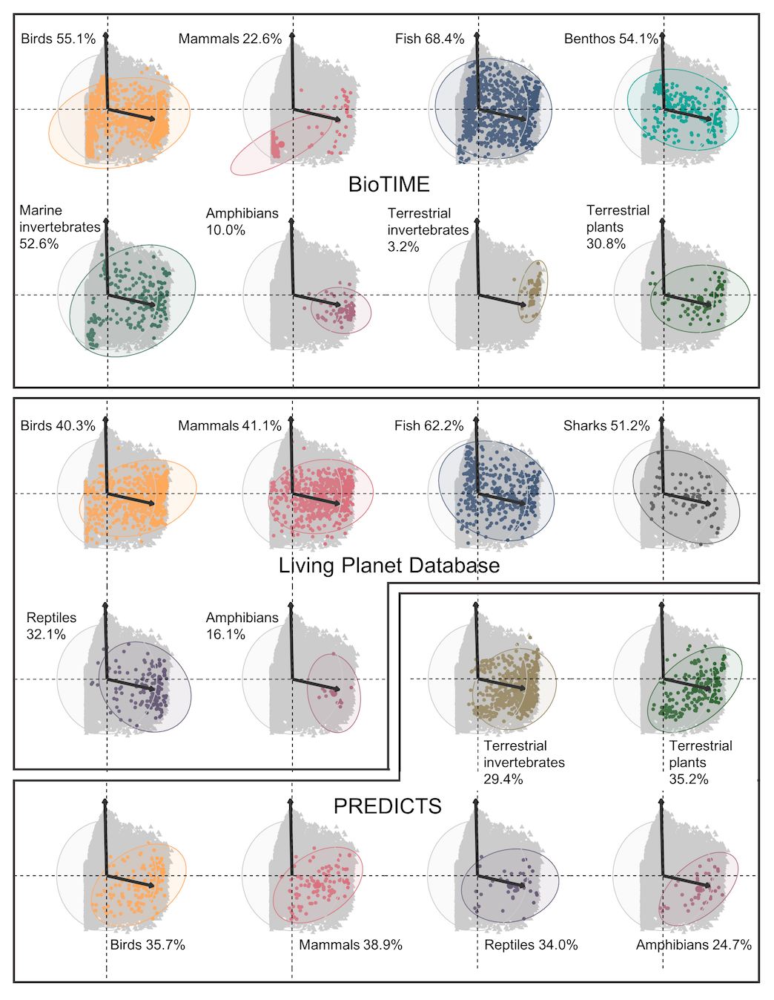

**Extended Data Figure 1. Global change representation varies across taxa.** Figure shows Principal Component Analysis of the magnitudes of human use, climate change, human population density, pollution and invasion potential across the locations of the Living Planet, BioTIME and PREDICTS databases, split by taxa, as well as one million randomly sampled locations across the full extent of the globe (in grey). For example, in the Living Planet Database, amphibians occupy the part of global change space that corresponds with moderate to high human population density and relatively low climate change. PCA axes omitted for visual clarity. Upwards PCA arrow shows climate change, arrow pointing right shows human population density. Arrows show direction and magnitude of PCA scores. Human use, pollution and invasion potential were correlated with human population density. For details on the global change driver layers, see Bowler et al. 2020. Annotations show the percentage overlap between the 95% prediction ellipses covered by random sampling of global change space and the variation in global change sampled by the different databases across taxa.

**Extended Data Table S1. Model outputs for all statistical analyses.** Term names starting with “b” refer to fixed effects and sigma indicates the residual variance. Continuous variables (intensities of global change drivers) were scaled between zero and one to make them comparable. We used Bayesian general linear models and we analyzed the terrestrial and marine data separately.

|  |  |  |  |  |  |
| --- | --- | --- | --- | --- | --- |
| **Model** | **Term** | **Estimate** | **Lower 95% CI** | **Upper 95% CI** | **Rhat** |
| Terrestrial global change drivers across databases and the world | b_intercept | 0.518 | 0.507 | 0.528 | 1.002 |
| b_samplinglivingplanet | 0.070 | 0.058 | 0.081 | 1.001 |
| b_samplingbiotime | -0.144 | -0.157 | -0.131 | 1.002 |
| b_samplingpredicts | -0.024 | -0.038 | -0.010 | 1.001 |
| b_drivercumulative | -0.109 | -0.123 | -0.094 | 1.002 |
| b_driverhuman_population | -0.379 | -0.393 | -0.365 | 1.002 |
| b_driverhuman_use | -0.113 | -0.127 | -0.098 | 1.001 |
| b_driverinvasions | -0.350 | -0.365 | -0.336 | 1.001 |
| b_driverpollution | -0.290 | -0.305 | -0.276 | 1.001 |
| b_samplinglivingplanet.drivercumulative | 0.072 | 0.056 | 0.089 | 1.001 |
| b_samplingbiotime.drivercumulative | 0.391 | 0.372 | 0.409 | 1.002 |
| b_samplingpredicts.drivercumulative | 0.199 | 0.179 | 0.218 | 1.001 |
|  | b_samplinglivingplanet.driverhuman_population | 0.298 | 0.282 | 0.315 | 1.001 |
|  | b_samplingbiotime.driverhuman_population | 0.723 | 0.706 | 0.742 | 1.002 |
|  | b_samplingpredicts.driverhuman_population | 0.568 | 0.549 | 0.588 | 1.001 |
|  | b_samplinglivingplanet.driverhuman_use | -0.061 | -0.077 | -0.044 | 1.001 |
|  | b_samplingbiotime.driverhuman_use | 0.328 | 0.311 | 0.347 | 1.001 |
|  | b_samplingpredicts.driverhuman_use | 0.198 | 0.179 | 0.219 | 1.001 |
|  | b_samplinglivingplanet.driverinvasions | 0.362 | 0.345 | 0.378 | 1.001 |
|  | b_samplingbiotime.driverinvasions | 0.787 | 0.767 | 0.805 | 1.002 |
|  | b_samplingpredicts.driverinvasions | 0.551 | 0.531 | 0.571 | 1.000 |
|  | b_samplinglivingplanet.driverpollution | 0.219 | 0.204 | 0.236 | 1.000 |
|  | b_samplingbiotime.driverpollution | 0.675 | 0.657 | 0.693 | 1.001 |
|  | b_samplingpredicts.driverpollution | 0.432 | 0.413 | 0.453 | 1.000 |
|  | sigma | 0.231 | 0.230 | 0.232 | 1.000 |
| Marine global change drivers across databases and the world | b_intercept | 0.484 | 0.460 | 0.507 | 1.000 |
| b_samplinglivingplanet | 0.002 | -0.024 | 0.027 | 1.000 |
| b_samplingbiotime | 0.013 | -0.010 | 0.037 | 1.000 |
| b_drivercumulative | -0.030 | -0.064 | 0.004 | 1.001 |
| b_driverhuman_population | -0.194 | -0.226 | -0.157 | 1.001 |
| b_driverhuman_use | -0.110 | -0.144 | -0.076 | 1.000 |
| b_driverinvasions | -0.133 | -0.168 | -0.101 | 1.000 |
|  | b_driverpollution | -0.155 | -0.188 | -0.121 | 1.000 |
|  | b_samplinglivingplanet.drivercumulative | 0.121 | 0.085 | 0.160 | 1.001 |
|  | b_samplingbiotime.drivercumulative | 0.107 | 0.073 | 0.141 | 1.001 |
|  | b_samplinglivingplanet.driverhuman_population | 0.158 | 0.123 | 0.196 | 1.001 |
|  | b_samplingbiotime.driverhuman_population | 0.006 | -0.028 | 0.041 | 1.001 |
|  | b_samplinglivingplanet.driverhuman_use | 0.212 | 0.175 | 0.248 | 1.001 |
|  | b_samplingbiotime.driverhuman_use | 0.228 | 0.194 | 0.262 | 1.000 |
|  | b_samplinglivingplanet.driverinvasions | 0.201 | 0.165 | 0.236 | 1.000 |
|  | b_samplingbiotime.driverinvasions | 0.134 | 0.100 | 0.168 | 1.000 |
|  | b_samplinglivingplanet.driverpollution | 0.192 | 0.156 | 0.229 | 1.000 |
|  | b_samplingbiotime.driverpollution | 0.166 | 0.132 | 0.199 | 1.000 |
|  | sigma | 0.274 | 0.273 | 0.274 | 1.000 |
| Terrestrial temperature change (Living Planet Database) | b_intercept | 0.011 | 0.009 | 0.013 | 1.000 |
| b_periodduringmonitoring | 0.017 | 0.015 | 0.020 | 1.000 |
| sigma | 0.080 | 0.080 | 0.081 | 1.000 |
| Marine temperature change (Living Planet Database) | b_intercept | 0.004 | 0.001 | 0.007 | 1.000 |
| b_periodduringmonitoring | 0.013 | 0.009 | 0.017 | 1.000 |
| sigma | 0.050 | 0.048 | 0.051 | 1.000 |
| Terrestrial temperature change (BioTIME) | b_intercept | 0.027 | 0.024 | 0.031 | 1.000 |
| b_periodduringmonitoring | -0.011 | -0.017 | -0.007 | 1.000 |
| sigma | 0.104 | 0.102 | 0.105 | 1.000 |
| Marine temperature change (BioTIME) | b_intercept | 0.010 | 0.009 | 0.012 | 1.000 |
| b_periodduringmonitoring | 0.008 | 0.007 | 0.010 | 1.000 |
| sigma | 0.058 | 0.057 | 0.058 | 1.000 |

**Extended Data Table S2. Metadata and web links for each variable dataset included in the global change driver layers used to quantify global change space and extract driver information for the sites represented by the Living Planet, BioTIME and PREDICTS databases.** The table is extracted from Bowler et al. 20203 where there are additional driver data details. In the “Realm” column “T” stands for terrestrial and “M” for marine.

|  |  |  |  |  |  |
| --- | --- | --- | --- | --- | --- |
| **Variable** | **Realm** | **Data Layer** | **Time series** | **Resolution** | **Description/Url/Reference** |
| **Temperature** | T | CRU v 4.02 | Yes | 0.5° | mean monthly and yearly temperatures (°C)  <https://crudata.uea.ac.uk/cru/data/hrg/>  (Harris *et al.* 2014) |
| **Aridity change** | T | CRU v 4.02 | Yes | 0.5° | ratio of mean monthly and yearly pet (mm day-1) and precipitation (mm)  <https://crudata.uea.ac.uk/cru/data/hrg/>  (Harris *et al.* 2014) |
| **Sea surface temperature** | M | HadISST | Yes | 1° | mean monthly and yearly sea surface temperatures (°C)  <https://www.metoffice.gov.uk/hadobs/hadisst/data/download.html>  (Rayner *et al.* 2003) |
| **Ocean acidification** | M | Ocean Acidification | Yes*  (2000-2009 vs 1870) | 1 km2 | change in aragonite saturation state  <https://www.nceas.ucsb.edu/globalmarine/impactbyactivity>  (Halpern *et al.* 2008) |
| **Pasture** | T | Pasture fraction | No  (2000) | 5' | fraction of cell area (0-1) based on agricultural inventory data and satellite-derived land cover data  <http://www.earthstat.org/>  (Ramankutty *et al.* 2008) |
| **Cropland** | T | Cropland fraction | No  (2005) | 5' | fraction of cell area (0-1) based on national and subnational agricultural data and satellite-derived land cover data  (Fritz *et al.* 2015) |
| **Cattle density** |  | Gridded Livestock of the World | No  (2005) | 1 km | FAOSTAT national estimates and modelled downscaling  (Robinson *et al.* 2014) |
| **Forest loss** | T | Land-Use Harmonization 2 (primary forest cover) | Yes | 0.25° | fraction of cell area (0-1) using FAO national wood harvest volume data and an ecosystem model  <http://luh.umd.edu/>  (Hurtt *et al.* (in prep)) |
| **Urban cover** | T | MODIS | No  (2001) | 5' | Urban cover (0 or 1) based on satellite-derived land cover data  <http://glcf.umd.edu/data/lc/>  (Friedl *et al.* 2010) |
| **Fishing** | M | Commercial fishing layers | No  (1999-2003) | 1 km2 | tons of caught fish per ton of carbon  <https://www.nceas.ucsb.edu/globalmarine/impactbyactivity>  (Halpern *et al.* 2008) |
| **Population density** | T | SEDAC population data v4 | No  (2000) | 30” | UN-adjusted population density  <http://sedac.ciesin.columbia.edu/data/set/gpw-v4-population-density/data-download>  (Center for International Earth Science Information Network - CIESIN - Columbia University 2017) |
| **Coastal population** | M | Coastal population | No  (1992-2002) | 1 km2 | number of people within 25 km radius  <https://www.nceas.ucsb.edu/globalmarine/impactbyactivity>  (Halpern *et al.* 2008) |
| **N deposition** | T | Atmospheric nitrogen deposition | No  (1993) | 5º x 3.75º | mg N/m2 of total inorganic nitrogen (N), NHx (NH3 and NH4+), and NOy  <http://webmap.ornl.gov/ogcdown/dataset.jsp?ds_id=830>  (Dentener 2006) |
| **Fertilizer application** | T | Nitrogen fertilizer application (v1) | No  (1994-2001) | 0.5° | kg of Nitrogen fertilizer per hectare of cropland  <http://sedac.ciesin.columbia.edu/data/set/ferman-v1-nitrogen-fertilizer-application>  (Potter *et al.* 2010) |
| **Pesticides** | T | Riverthreat.net: Pesticide loading | No  (2000) | 0.5° | kg of pesticide per hectare of cropland  <http://www.riverthreat.net/data.html>  (Vorosmarty *et al.* 2010) |
| **Light pollution** | T/M | NOACC NGDC stable night lights | No  (2006) | 1 km | radiance values  <https://knb.ecoinformatics.org/#view/doi:10.5063/F15718ZN>  (Halpern *et al.* 2008) |
| **Coastal pollution** | M | Pesticide, Fertilizer | No  (1993-2002) | 1 km2 | average annual use in agricultural land  <https://knb.ecoinformatics.org/#view/doi:10.5063/F15718ZN>  (Halpern *et al.* 2008) |
| **Shipping pollution** | M | Shipping pollution | No  (2004-2005) | 1 km2 | ship activity (number of ships)  <https://knb.ecoinformatics.org/#view/doi:10.5063/F15718ZN>  (Halpern *et al.* 2008) |
| **Invasions** | T | Accessibility (Travel time) | No  (2000) | 30” | travel time to major cities (in hours and days)  <http://forobs.jrc.ec.europa.eu/products/gam/>  (Nelson 2008) |
| **Invasions** | M | Port volume  (cargo volume at ports) | No  (1999-2003) | 1 km2 | amount of cargo traffic at ports  <https://knb.ecoinformatics.org/#view/doi:10.5063/F15718ZN>  (Halpern *et al.* 2008) |